|  |  |  |  |  |  |
| --- | --- | --- | --- | --- | --- |
| Date | 6-Dec-22 | | | Tester Name | Mohammad Yusuf |
| Environment | Penfax - Test | | | Login used |  |
| Operating System | Select OS | Version: | Update: | | |
| Software Used | Select Software | Version: | Update: | | |
| Select Software | Version: | Update: | | |
| Release version |  | | | | |
| Title | M17 Contributions & DCT | | | | |
| Test Type | Regression | | | | |
| Test Scenario | M17.12 Creating a Layoff File | | | | |
|  |  | | | | |
| Expected Results | Layoff record should be available under Employee Profile and Member Status should become inactive. | | | | |
| Pass/Fail | Pass | | | JIRA# | N/A |

Describe your steps with screenshots:

1. Bring up an active MEPP member.

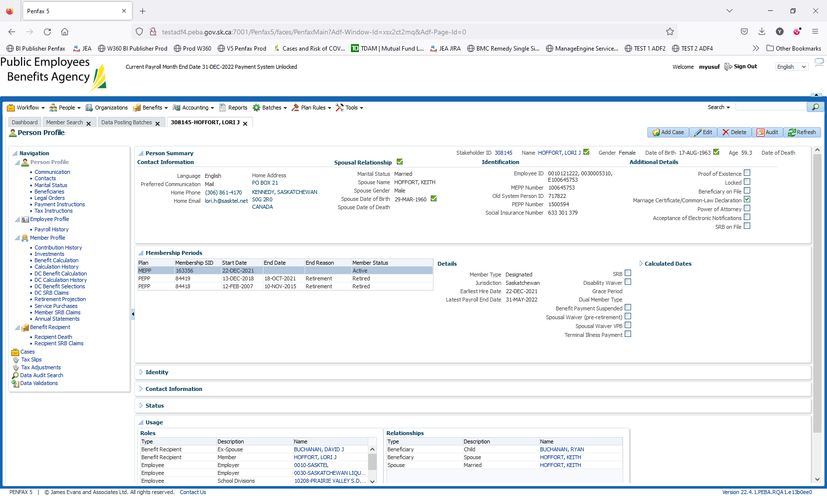

1. Log into MEPP DCT and select the Employer from the dropdown. Click on Create New File.

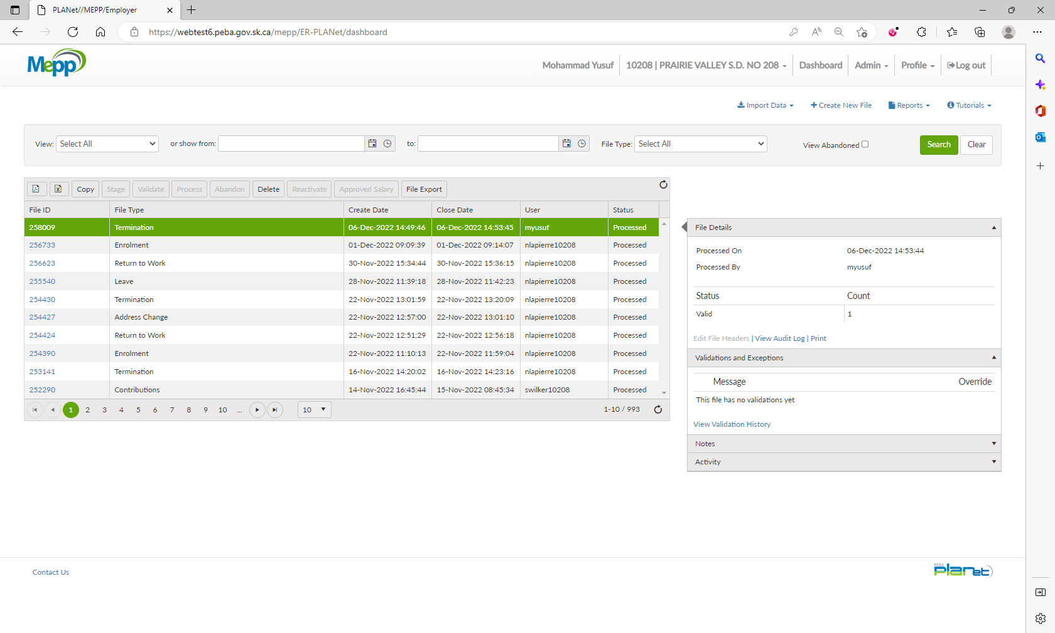

1. Select Layoff from the dropdown and click Create.

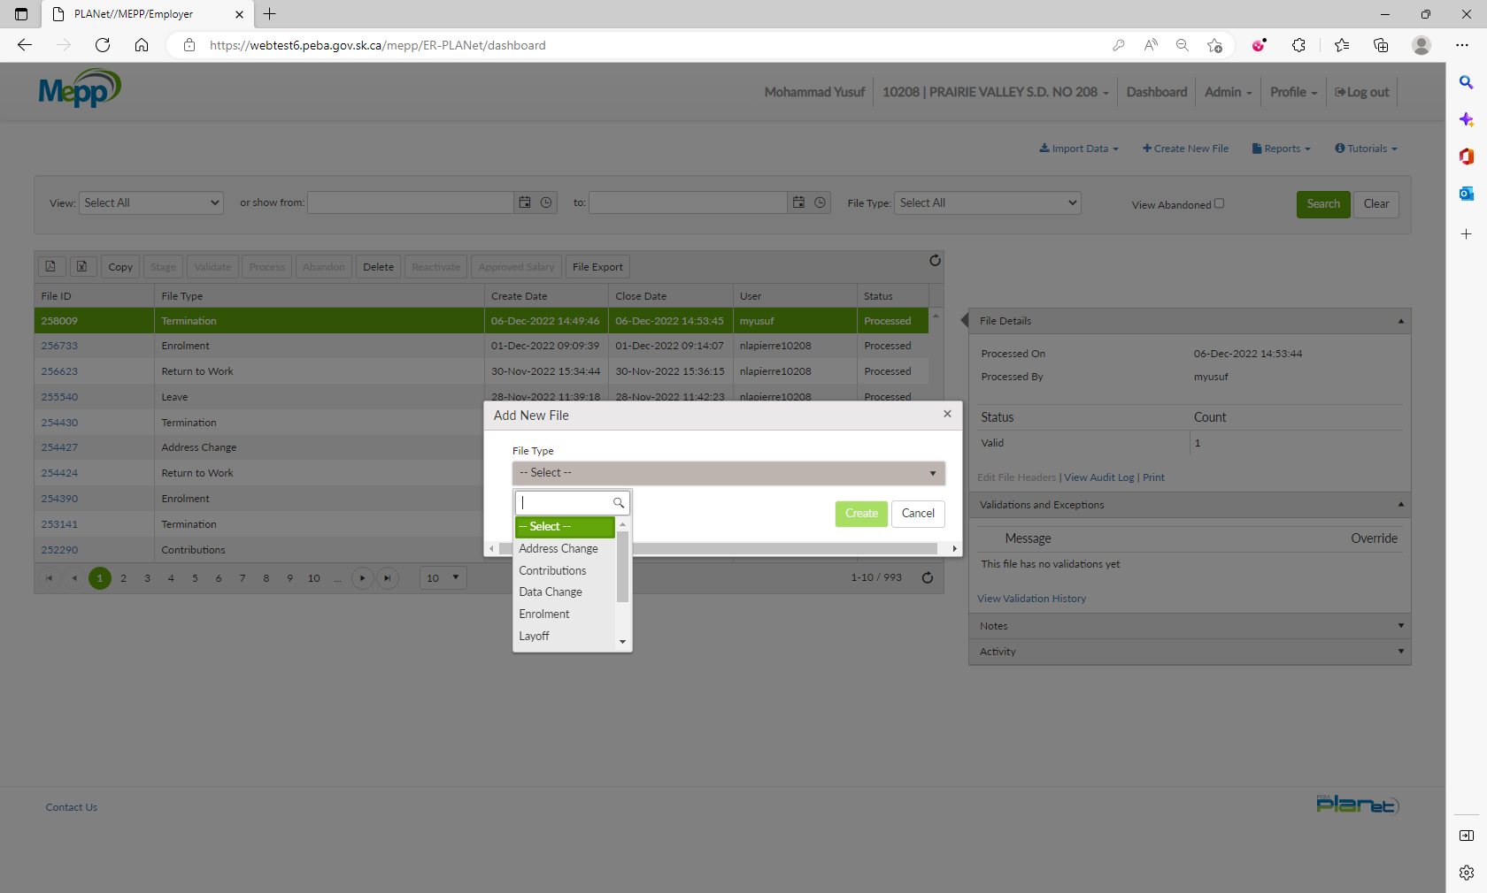

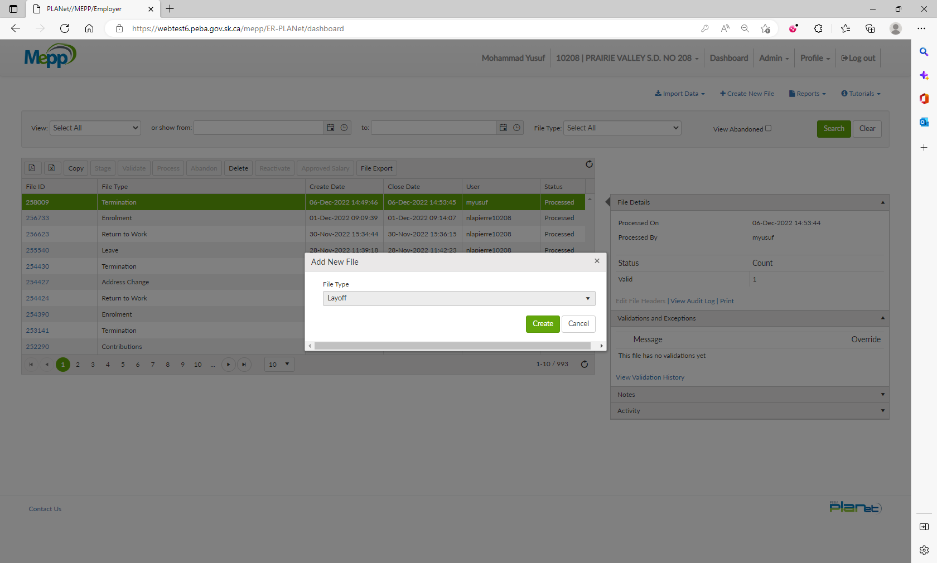

1. Click on File ID to add the transactions.

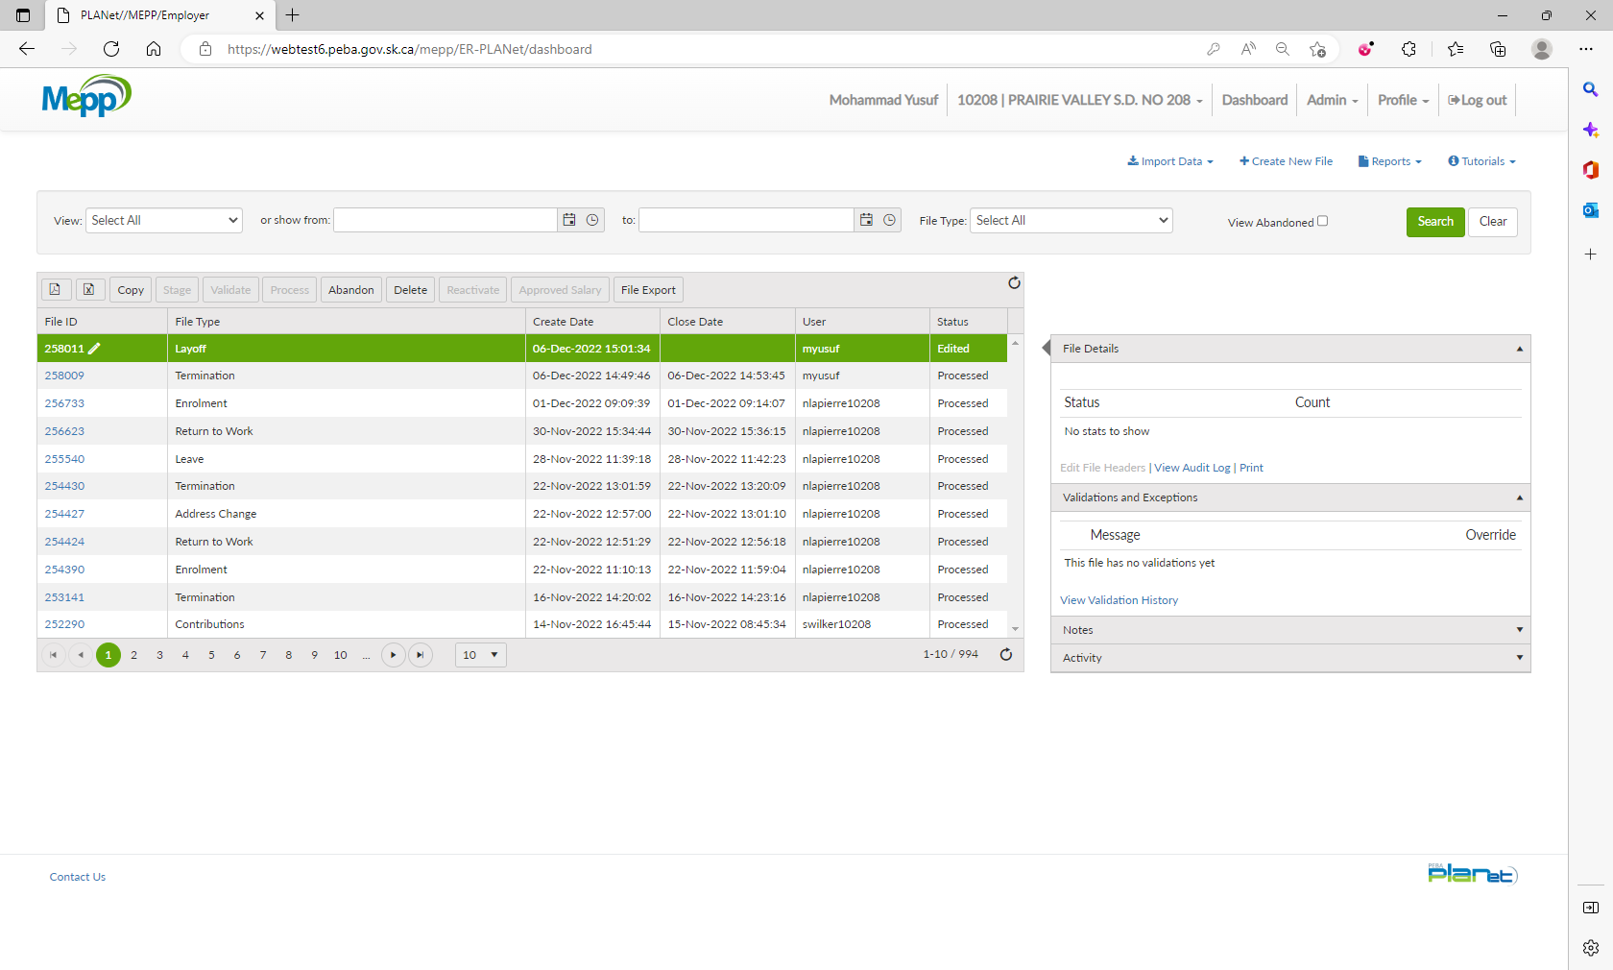

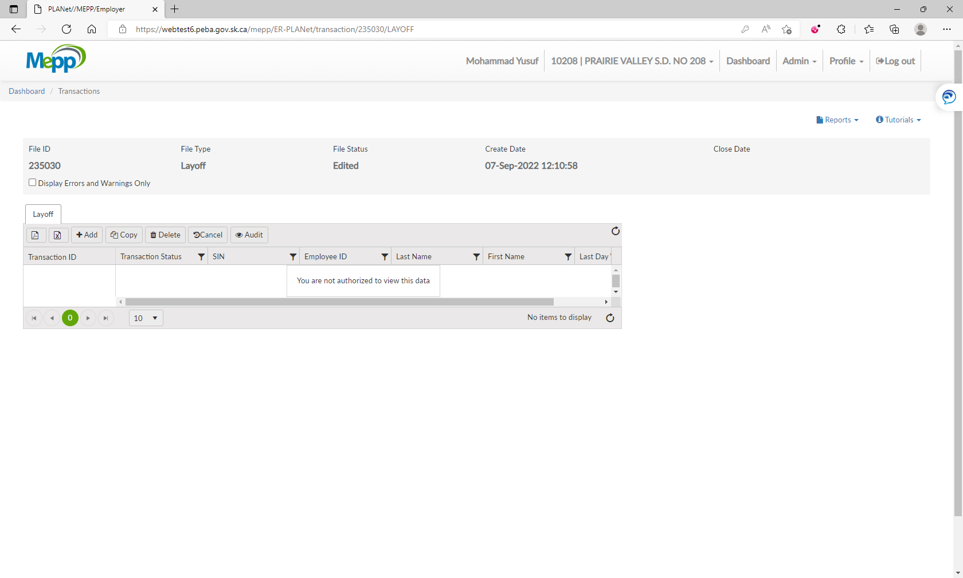

1. Input required details and click Save.

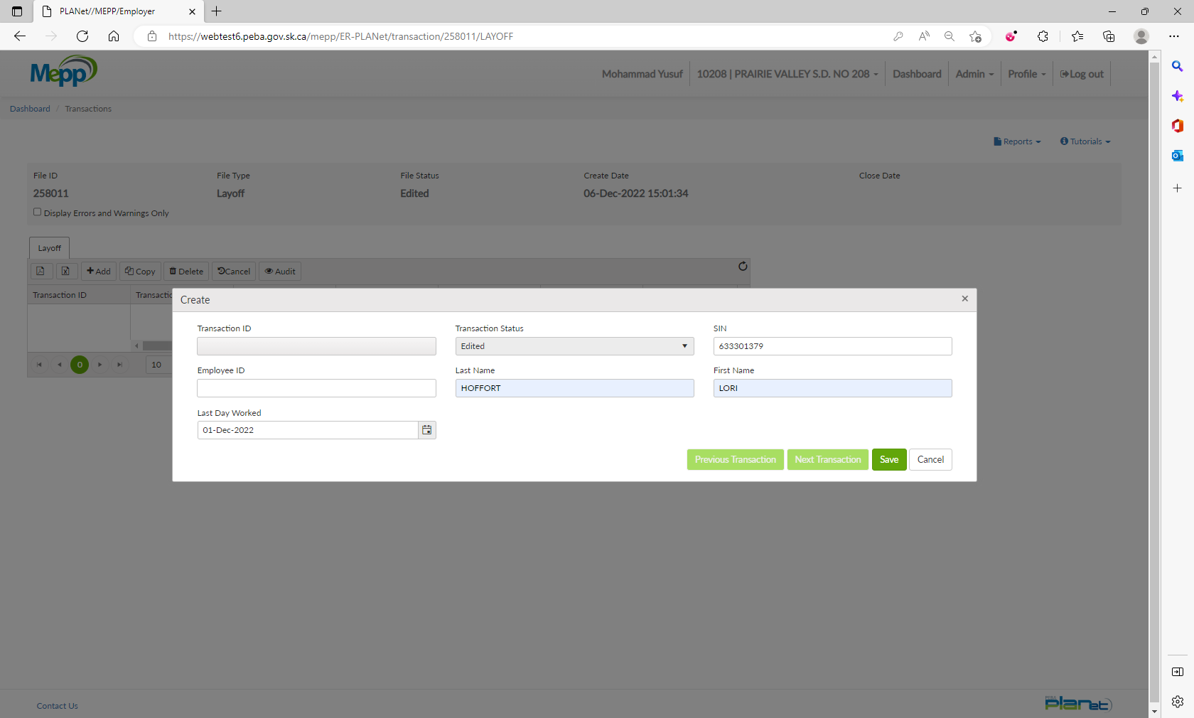

1. Under File Details, click on Validate and then Process.

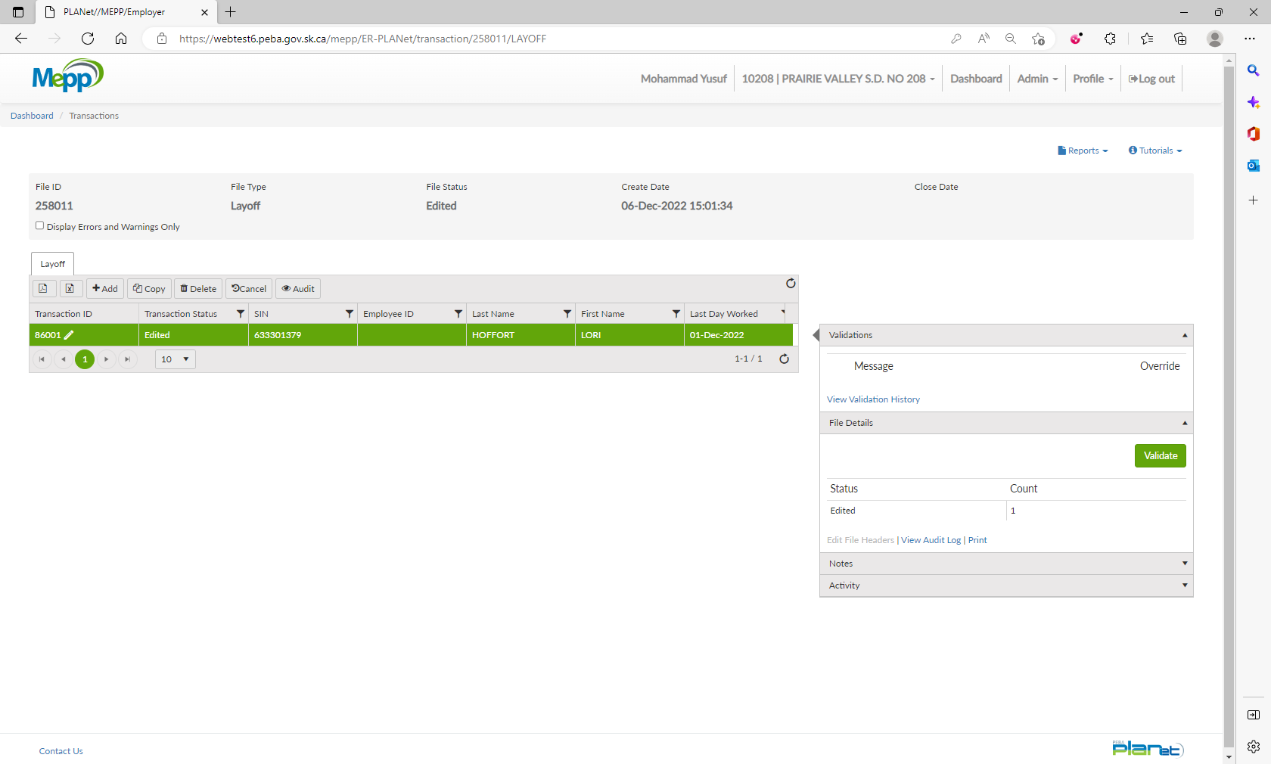

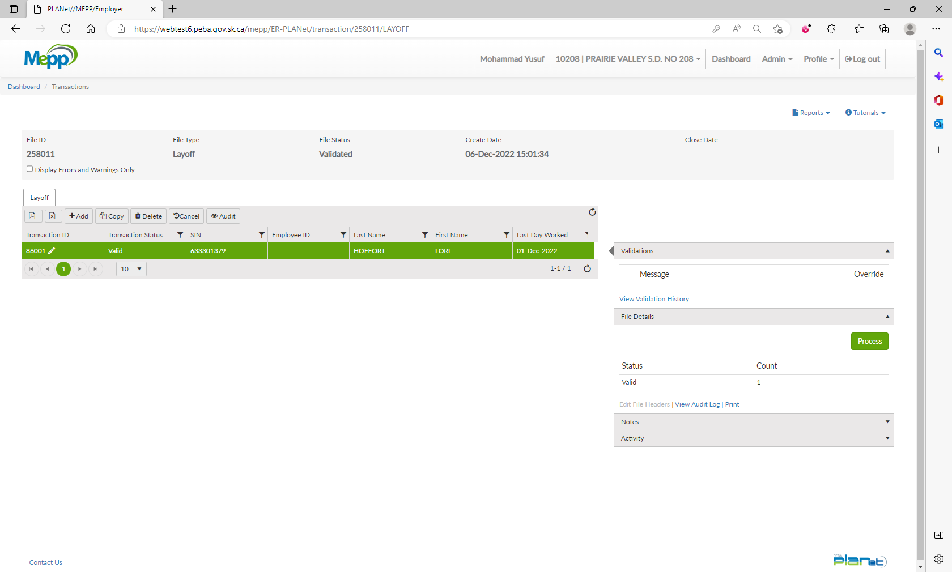

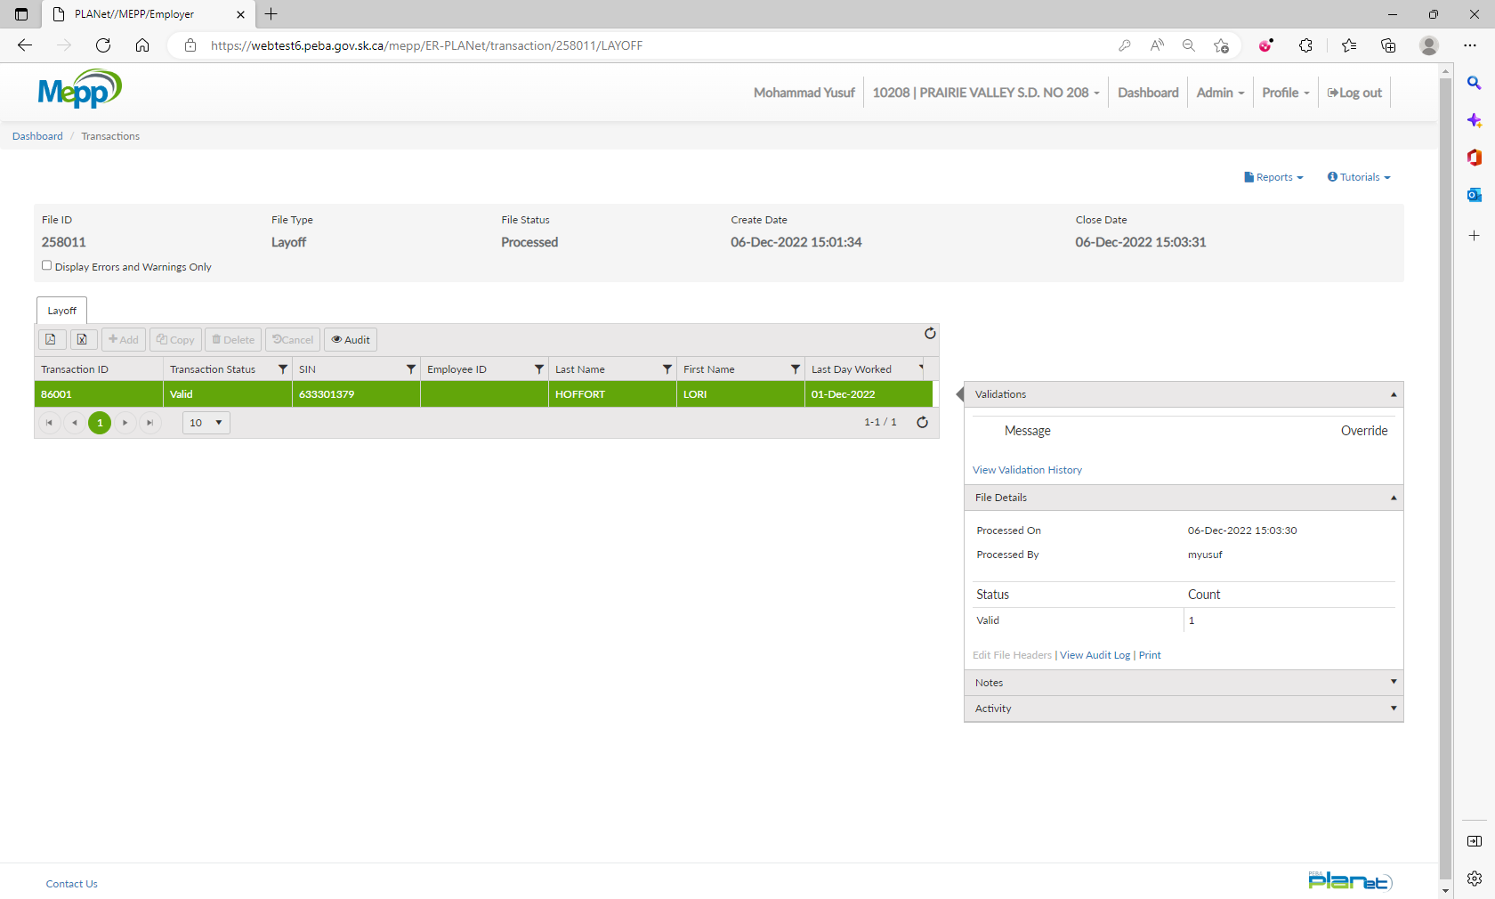

1. Go to Penfax -> Data Posting Batch -> Search by Batch Type and Employer.

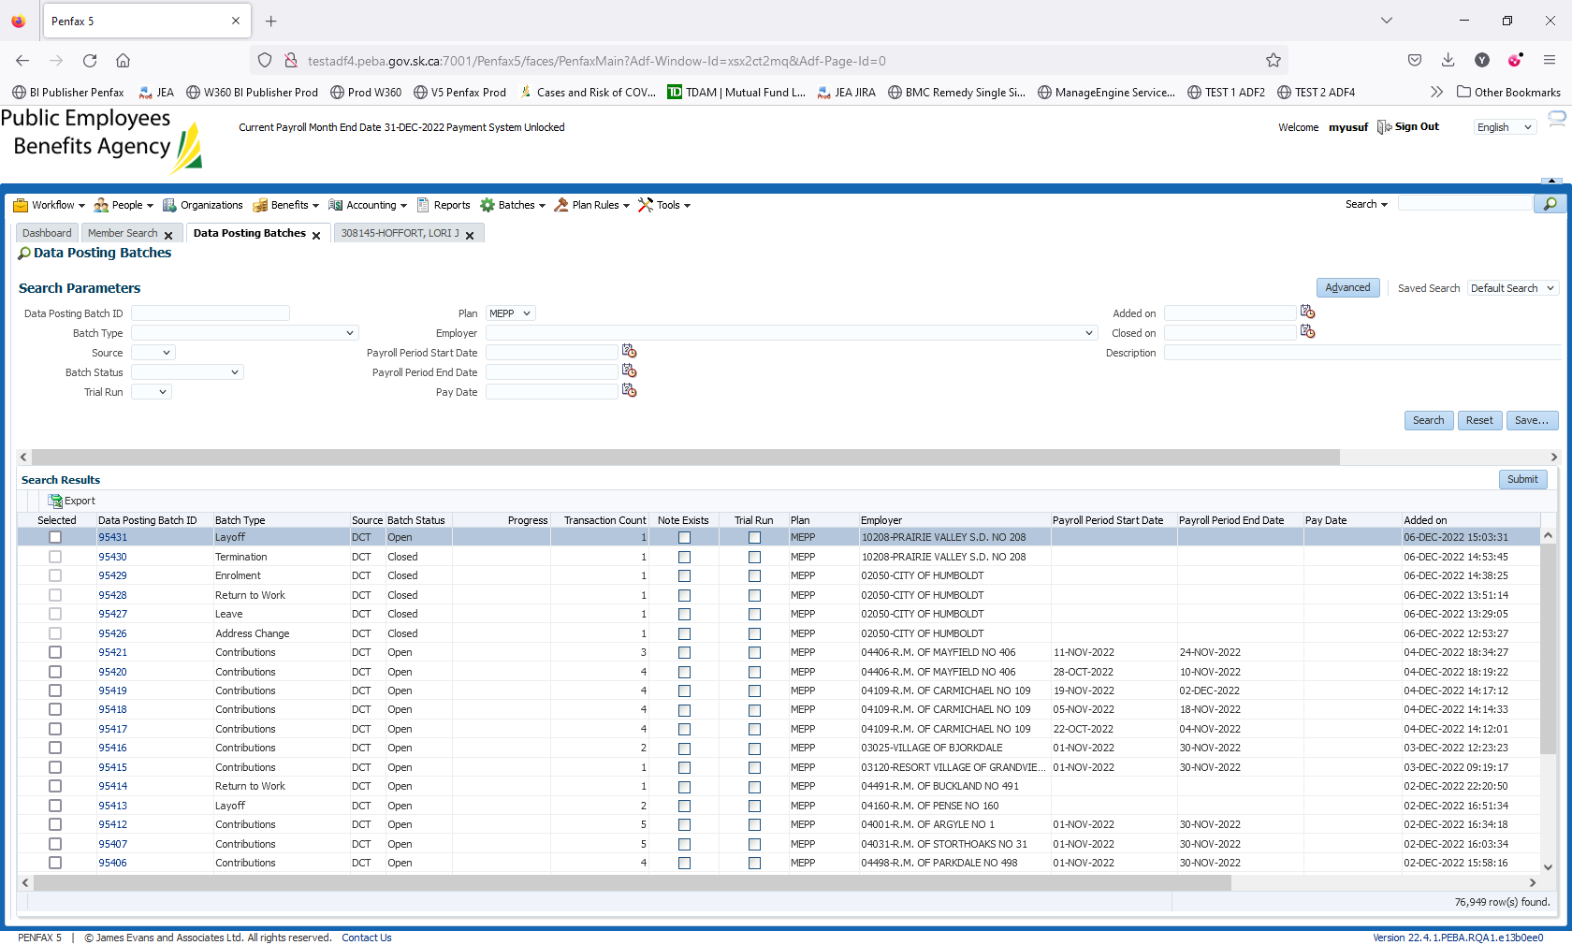

1. Open a batch you just processed through DCT. Go to Pending tab.

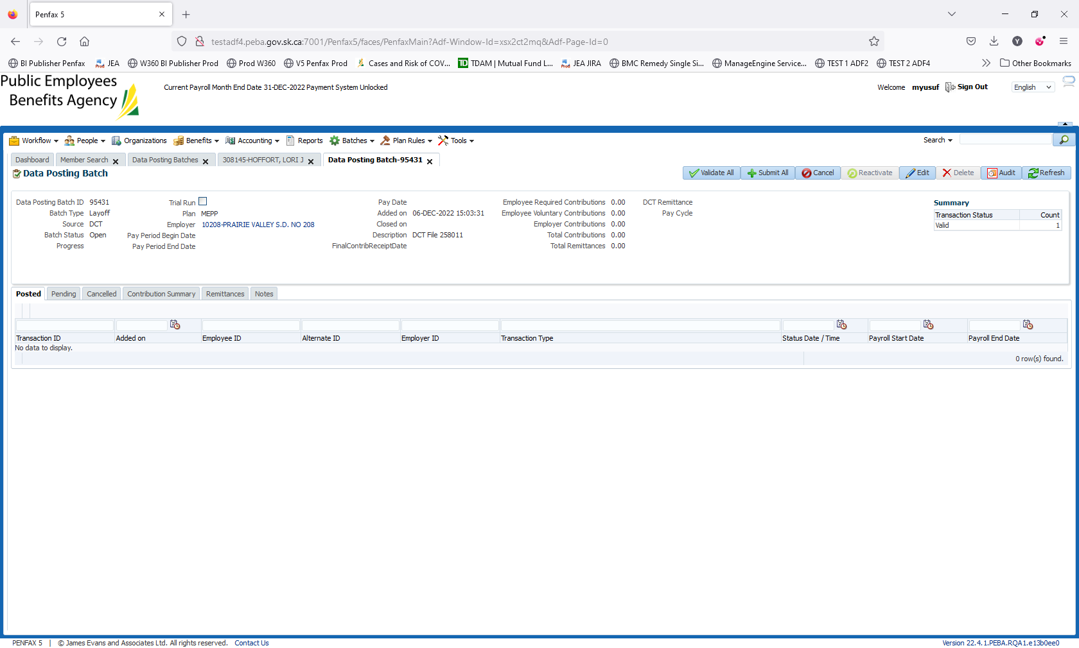

1. Click on Validate All and then Submit All.

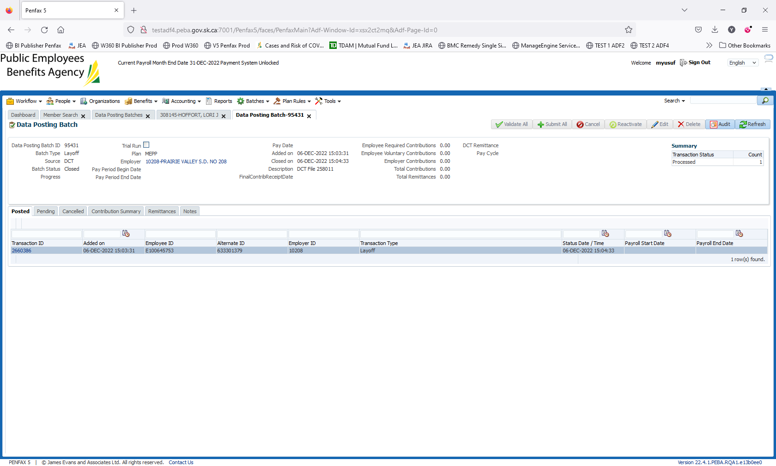

1. Batch is submitted/processed. Transaction is moved to Posted tab. Batch Status is now Closed.

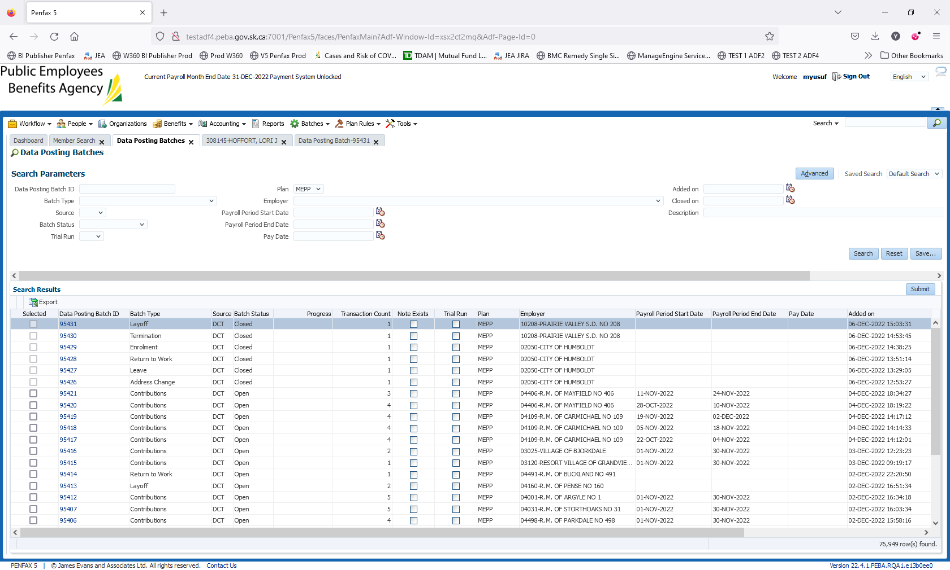

1. Bring up a member again to see the termination.

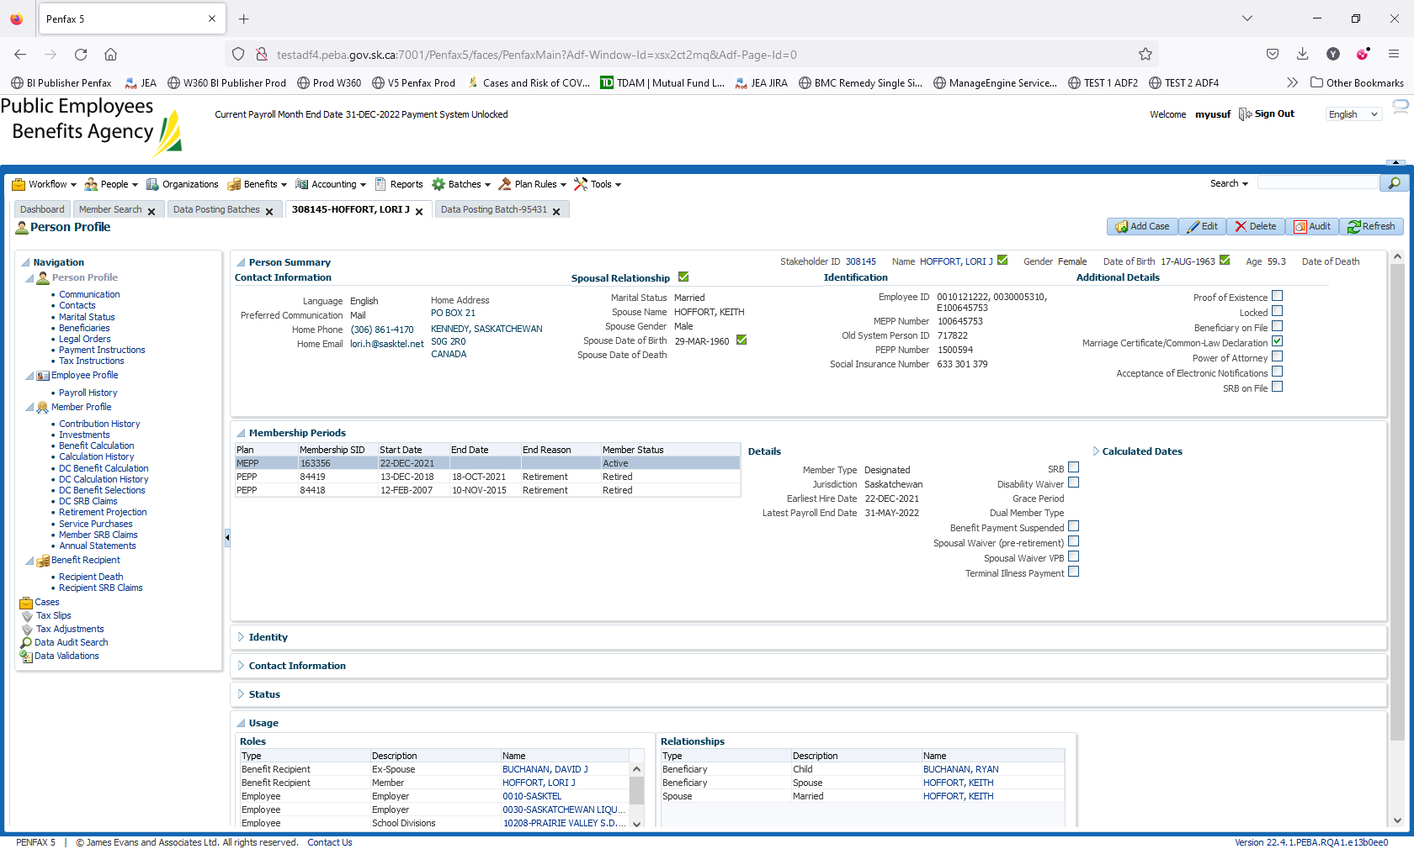

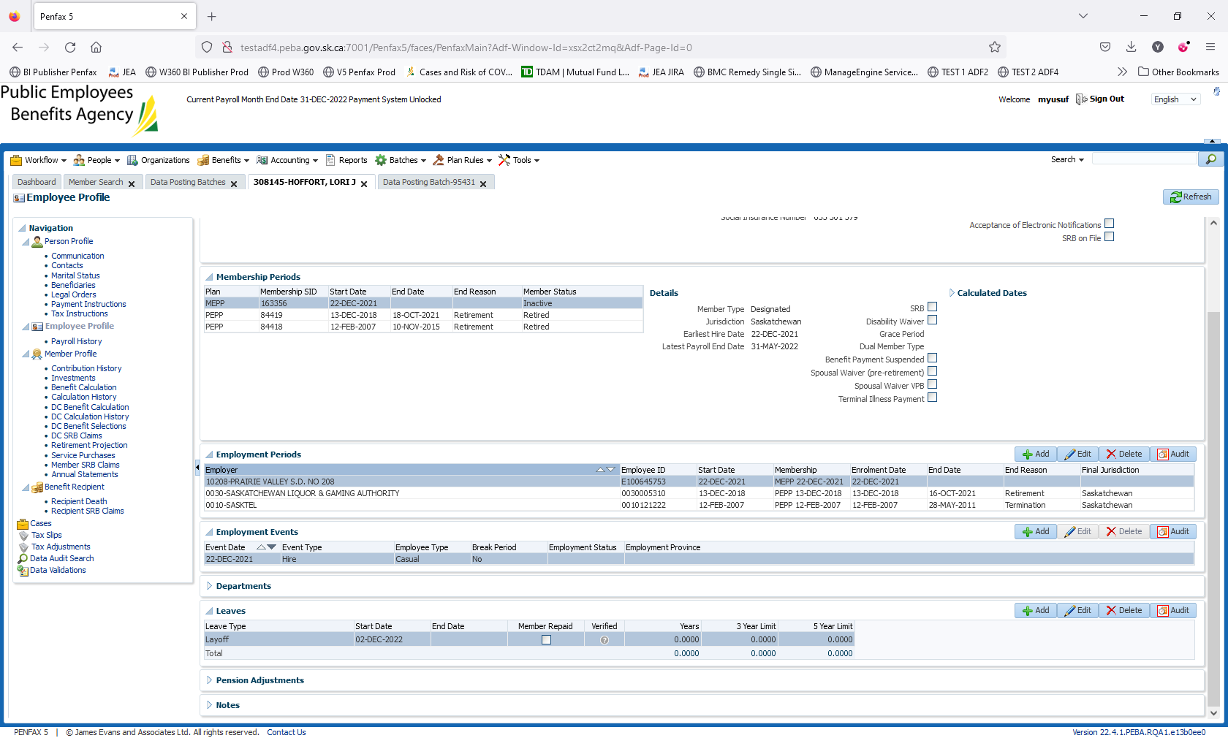

1. Member Status under Membership Periods becomes Inactive on the next day.

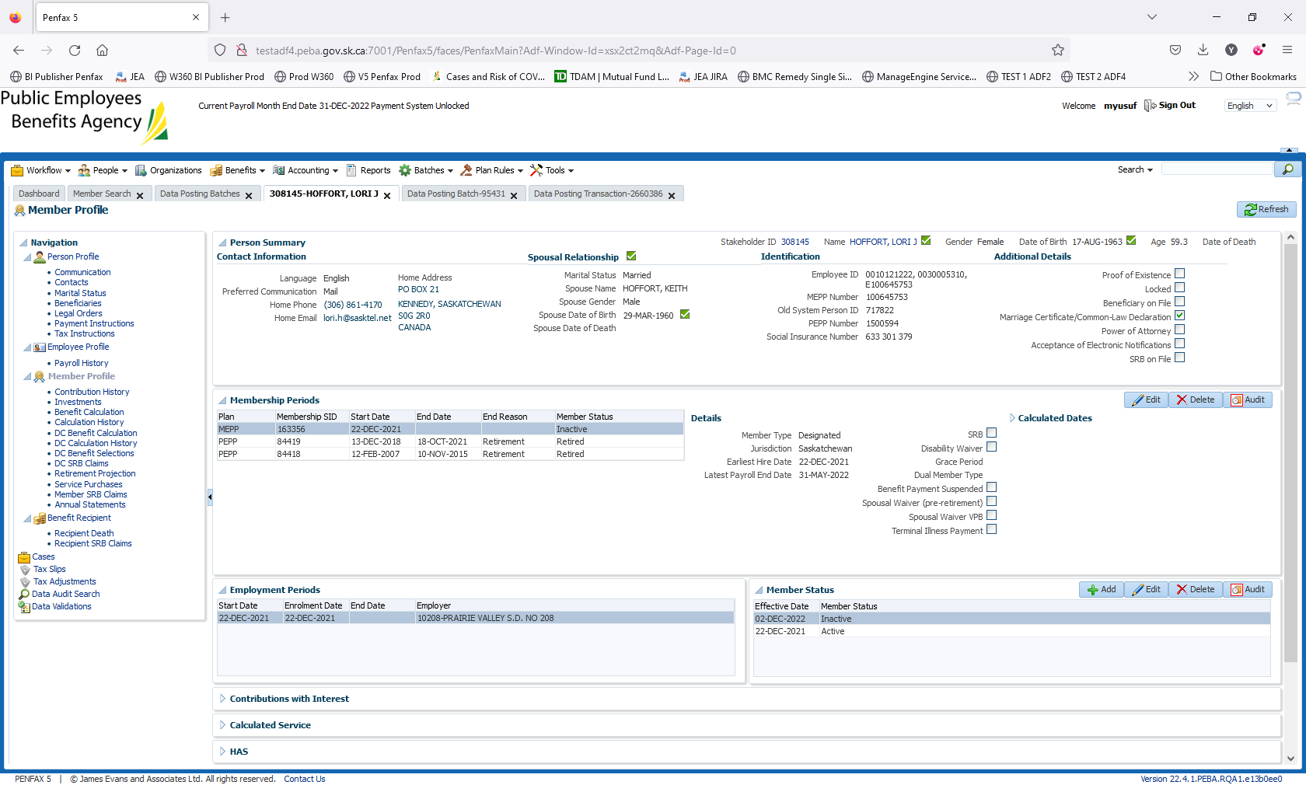

1. Go to Employee Profile -> Leaves. You can see a record for Layoff in there.

